OCTOBER 2017 705-864-1886
SUNDAY | MONDAY | TUESDAY | WEDNESDAY | THURSDAY | FRIDAY | SATURDAY
1  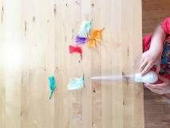 | 2  Turkey Baster  &  Feather Races  9:30-11:30  1:00-3:30 | 3  School Readiness  (closed to public)  9:30-11:30  &  Painting our Thankful  Tree & Leaves  1:00-3:30 | 4  Decorating a Pumpkin  9:30-11:30  &  Babies Afternoon  1:00-3:30  TUMBLE GYM  É.S.C.  5:50-6:50 | 5  Growing Minds  Sorting Games  9:30-11:30  1:00-3:30 | 6  Play Dough Turkey  9:30 – 12:30  Thanksgiving Lunch  closed p.m. | 7
8  HAPPY AND SAFE THANKSGIVING WEEKEND TO ALL | 9  CLOSED | 10  School Readiness  (closed to public)  9:30-11:30  &  Hand Print Wreath  1:00-3:30 | 11  Sensory Fun  9:30-11:30  &  Babies Afternoon  1:00 – 3:30  TUMBLE GYM  É.S.C.  5:50-6:50 | 12  Growing Minds  Stacking Games  9:30-11:30  1:00-3:30 | 13  Spider Web Fun  9:30-11:30  closed p.m. | 14  OPEN  Science Fun  9:30-11:30
15  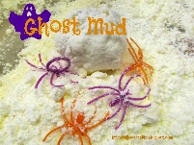 | 16  Ghost Mud  9:30-11:30  1:00-3:30 | 17  School Readiness  (closed to public)  9:30-11:30  &  Painting Nature with Nature  1:00-3:30 | 18  Pumpkin Goop  9:30-11:30  Babies Afternoon  1:00-3:30  TUMBLE GYM  É.S.C.  5:50-6:50 | 19  Growing Minds  Counting Games  9:30-11:30  1:00-3:30 | 20  Tangled Pumpkin  9:30-11:30  closed p.m. | 21  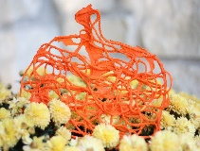
20  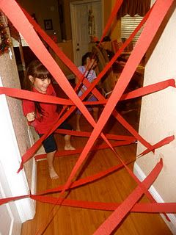 | 23  Giant Spider Web  9:30-11:30  1:00-3:30 | 24  School Readiness  (closed to public)  9:30-11:30  &  Pumpkin Carving  1:00-3:30 | 25  Pumpkin Memory Game with Foil  9:30-11:30  Babies Afternoon  1:00-3:30  TUMBLE GYM  É.S.C.  5:50-6:50 | 26  Seniors Visit  9:30-11:30  &  Growing Minds  Alphabet games  1:00-3:30 | 27  Wrapped Mummy  9:30-11:30  closed p.m. | OPEN  Science Fun  9:30-11:30
29  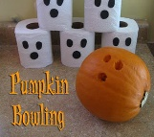 | 30  Bowling with Pumpkins  9:30-11:30  1:00-3:30 | 31  SCHOOL READINESS  CANCELLED  HALLOWE’EN PARTY !!!!  9:30-11:30 | WELCOME TO ALL OF OUR SCHOOL READINESS FAMILIES | PLEASE SIGN UP FOR OUR THANKSGIVING LUNCH | HAPPY AND SAFE TRICK OR TREATING TO ALL THE LITTLE MUNCHKINS

